**t::C++ 25 Fall 2016:: Assignment 4 Data Types**

**Student ID:** 10831438

**“Effective Googling”-** The ability to find what you need quickly through a search engine.

**Data Types (define and list keyword that is related.)**

**Boolean-** True or false

**Character-** A single letter, number, or symbol. Most of them correspond to keys on the keyboard.

**Integer-** A whole number

**Floating Point-** Any number with up to seven digits after the decimal

**Double Floating Point-** Any number with up to 15 or 16 digits after the decimal

**Valueless-** Data with no type

**Wide character-**

**Variables-** A container that holds data. It is a memory location where a value can be assigned.

**Variable limitations-** C++ requires variables to have a type. Variables also cannot be named a command or a keyword.

**Variable Declaration-**

**Symbol ( + ) in C++ programming basic arithmetic-** Addition

**Symbol ( * ) in C++ programming basic arithmetic-** Multiplication

**Symbol ( - ) in C++ programming basic arithmetic-** Subtraction

**Symbol ( / ) in C++ programming basic arithmetic-** Division

**Symbol ( = ) in C++ programming basic arithmetic-** Assigns values from the Right side to the Left Side

**LAB ASSIGNMENT**

### **Write a program to declare two integer , one float variables and assign 10, 15, and 12.6 to them respectively. It then prints these values on the screen.**

**Attach Snipping code below of source code and output.**

**Create program in Notepad and run through Command Line or Terminal.**

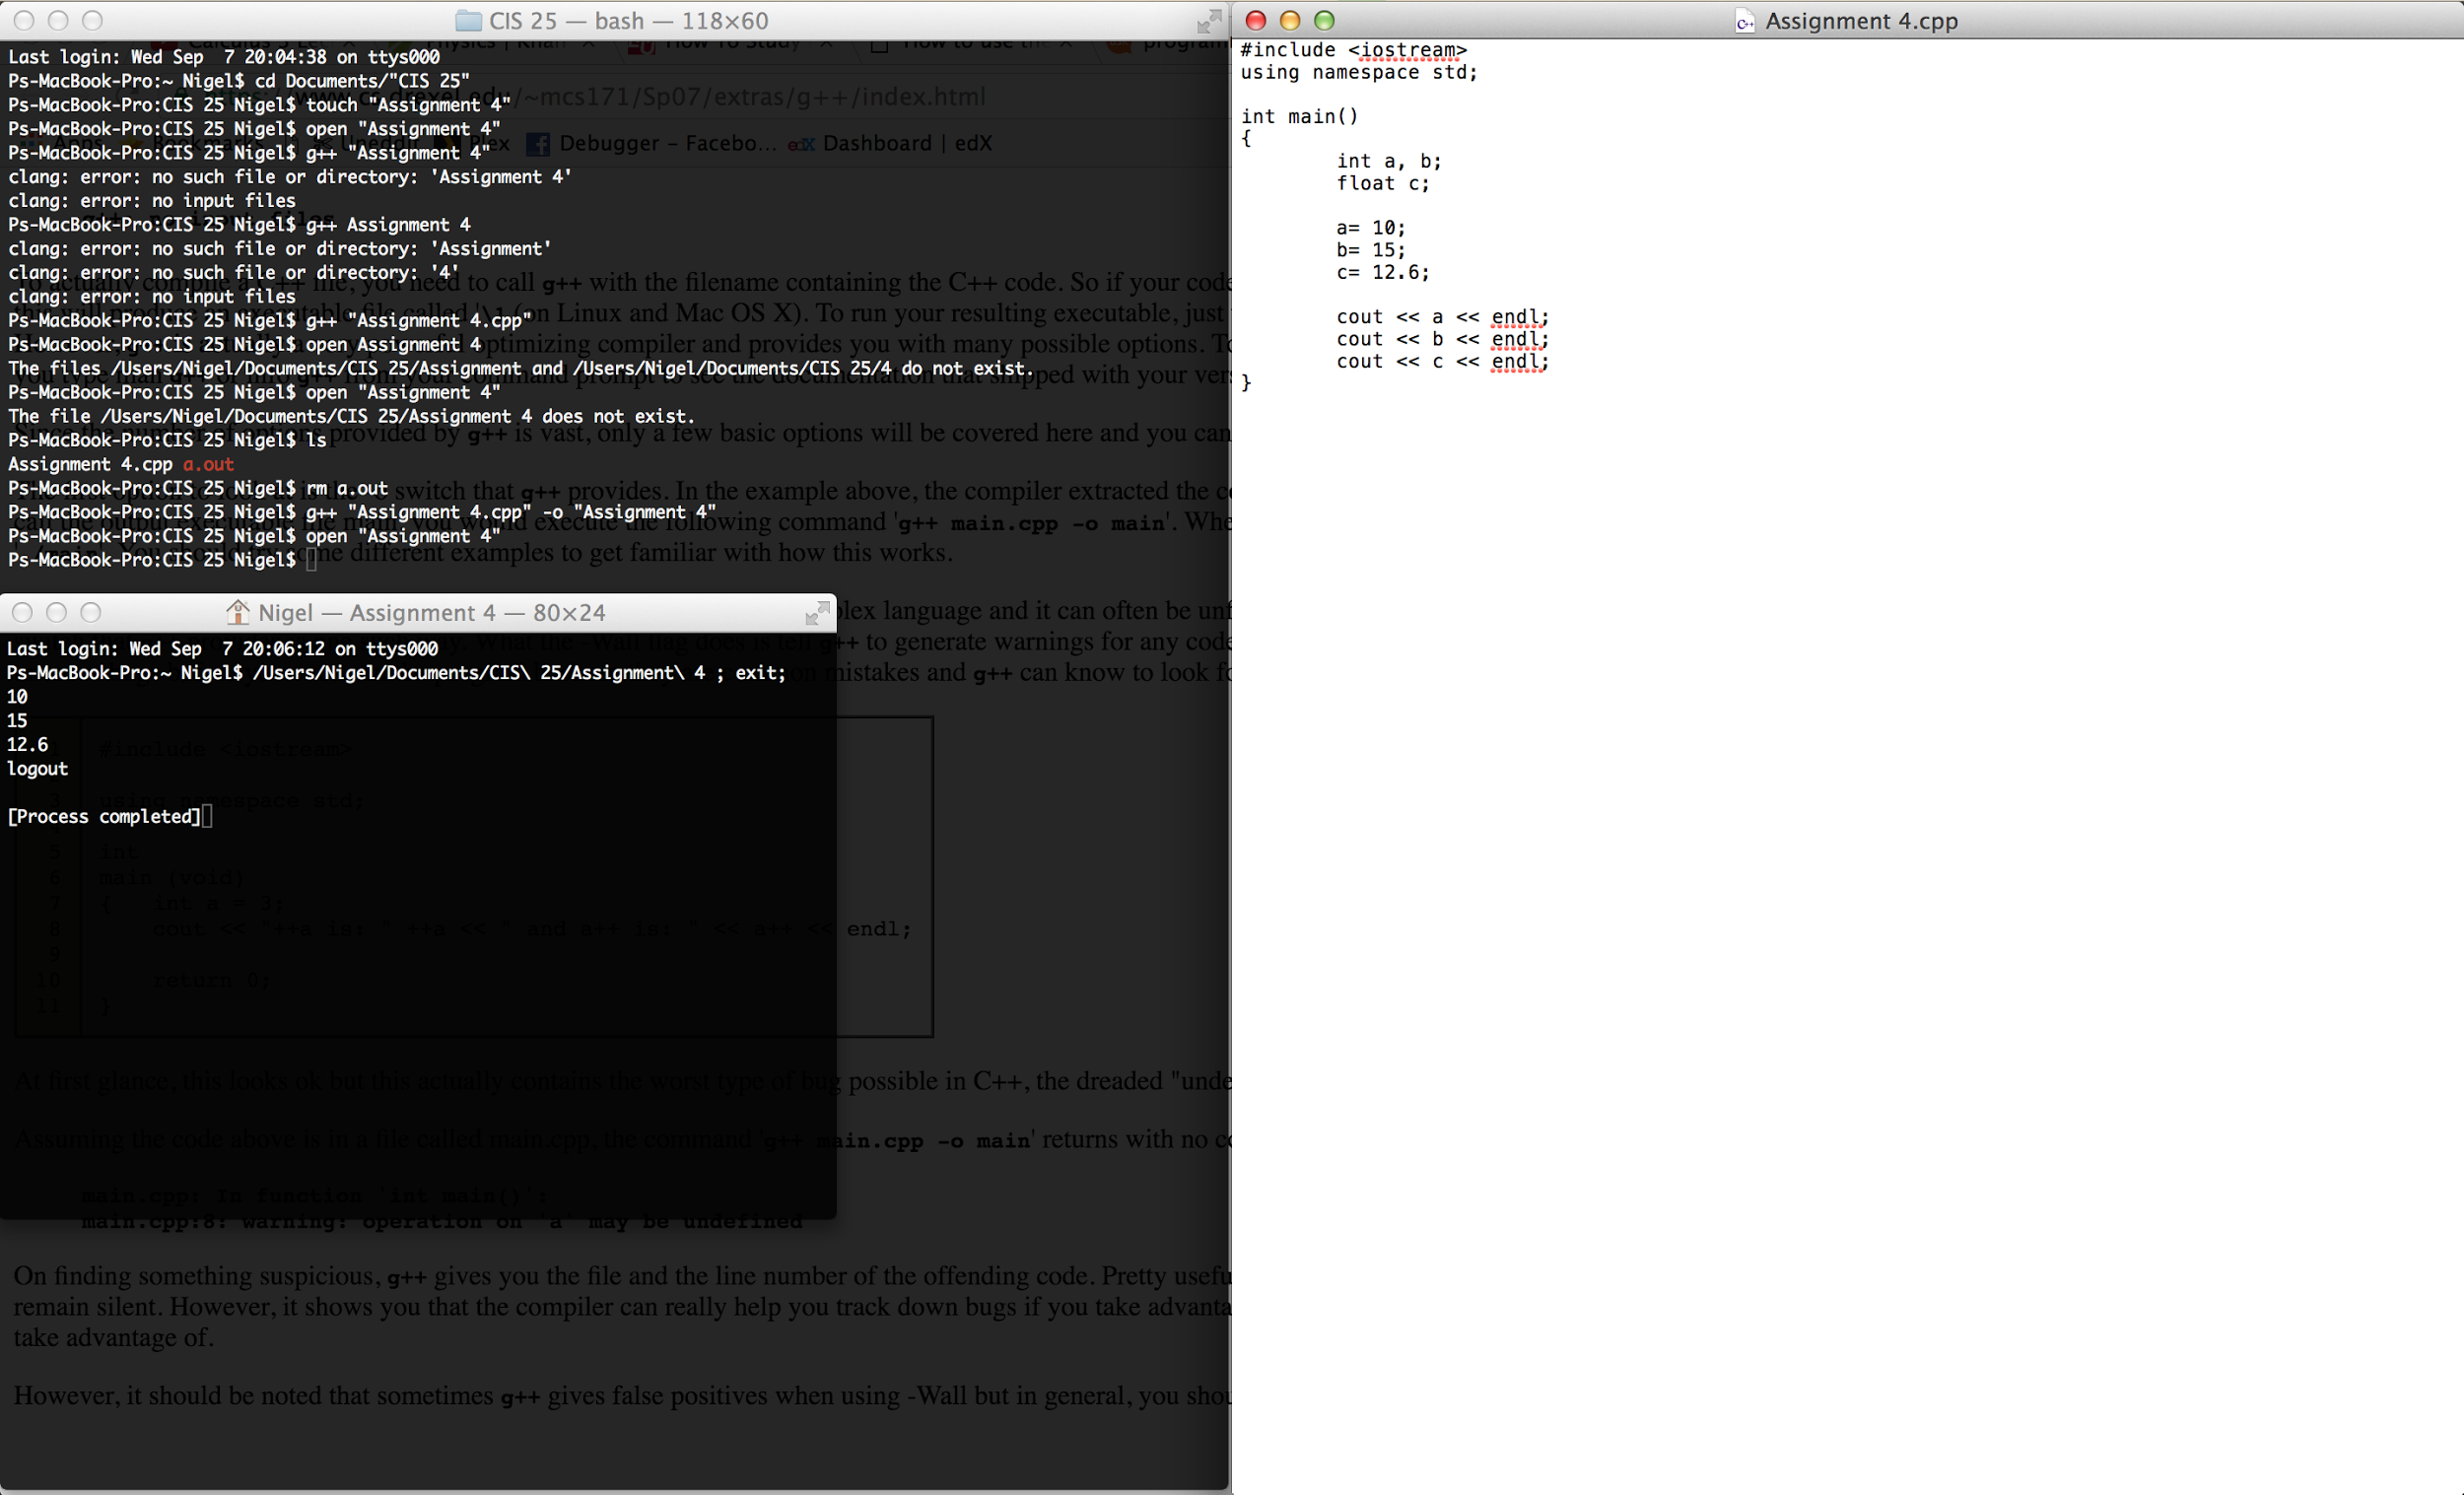

**Create a program that will calculate your weight on Mercury, Venus, Mars, and Earth’s moon.**

**Label the output so it is clear your weight on each independent planetary body.**

**Attach a snipping photo of the source code and output**

**(You are welcome to use the IDE or the Notepad text editor.)**

